Total Score
_______ / 48 points

B Complete the sentences with the correct words from the box.
handicrafts | landmarks | local food | volunteering | white-water rafting | wildlife
1. If you aren’t a good swimmer, going ____white-water rafting_____ may not be a good idea.
2. When I travel to another country, I like to try the ____local food_____.
3. If you want to see amazing ___wildlife____, try a trip to the rain forests
of Costa Rica.
4. My friend enjoys ___volunteering____ when she goes on vacation. Last year
she helped scientists study air pollution in Los Angeles.
5. I bought these little statues at a market in Peru. I love buying ____handicrafts____
when I travel.
6. The Eiffel Tower in Paris and the Empire State Building in New York City are well-known
____landmarks____.
B _______ / 6 points (1 point each)
C Circle the correct answers to complete the conversation.
A: I’m going to Italy this summer. My roommate says I should / ought to learn Italian.
¹
B: Well, it’s nice to know a little, but many Italians speak some English, so you
shouldn’t / don’t have to take lessons. Summer is the busy season, though,
²
so you’d better / you shouldn’t make a plane reservation now.
³
A: Good idea. What about a passport?
B: Americans who travel to Italy have to / should have passports. Everybody
⁴
needs one – it’s the law.
A: Well, thanks for your help. I’ve got / I must to go now. I’m meeting my roommate
⁵
for lunch at an Italian restaurant, and I shouldn’t / don’t have to be late!
⁶
C _______ / 6 points (1 point each)

D Write simple present statements with gerunds and the words in parentheses. Use contractions where possible.
1. (learn / a foreign language / be / not easy)
____Learning a foreign language is not easy._____
2. (she / be interested in / protect / the environment)
__She is interested in protecting the environment.____
3. (they / enjoy / go / to clubs)
___They enjoy going to clubs.____
4. (travel alone / not be / his favorite thing)
____Traveling alone isn’t his favorite thing._____
5. (he / prefer / listen / to live music)
____He prefers listening to music._____
6. (I / dislike / travel / by bus)
____I dislike traveling by bus._____
D _______ / 12 points (2 points each)
E Number the lines of the conversation in the correct order.
__5__ A: OK, room 14 is free. It has a great view. And here’s your key. Please
remember to give it back to me when you leave.
__2__ B: Yes. I’m Melinda Evans. I have a reservation for three nights.
__3__ A: Yes, I see your name right here. Would you like a room with an ocean
view or a mountain view?
__6__ B: No problem. I won’t forget. Thanks for your help.
____ A: Can I help you?
1
__4__ B: An ocean view, please.
__7__ A: Enjoy your stay.
E _______ / 6 points (1 point each)

F Read the webpage. Match the sentences with the people they describe.
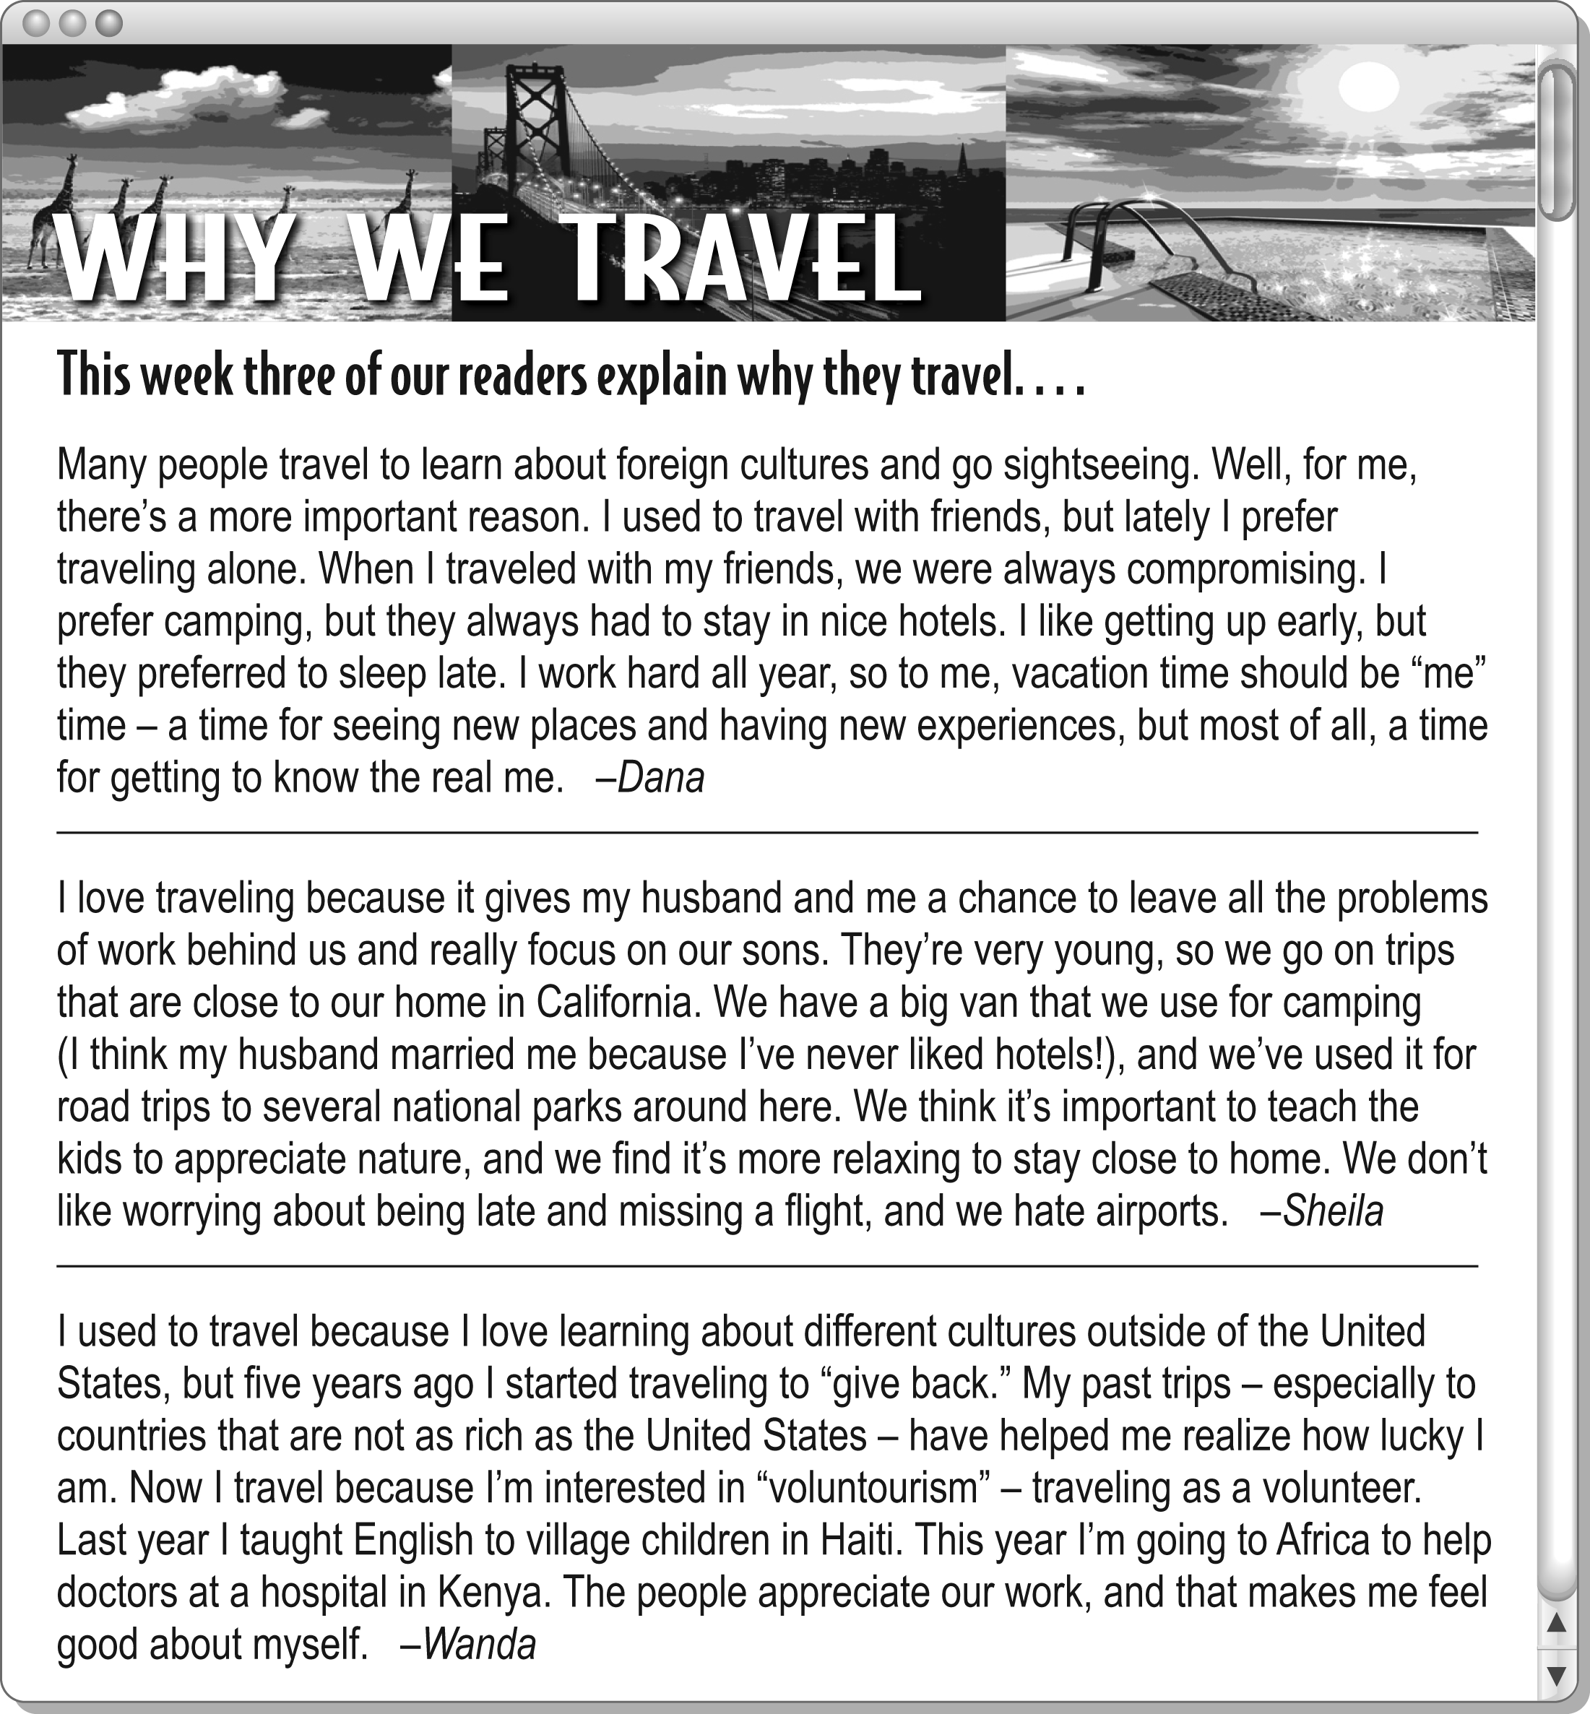

1. They’ve never been out of the United States. __c__ | a. Wanda
2. She thinks flying is not the best way to travel. __e__ | b. Dana’s friends
3. Their trips help them feel good about themselves. __d__ | c. Sheila’s children
4. They would rather camp than stay in a hotel. __f__ | d. Dana and Wanda
5. She might like going to a rain forest to help scientists. __a__ | e. Sheila
6. They probably wouldn’t go on a two-week camping trip. _b_ | f. Dana and Sheila
F _______ / 12 points (2 points each)

